**TATA CONSULTANCY SERVICES**

**HIRE AND TRAIN MODEL**

|  |
| --- |
| **STUDENT INTERNSHIP**  **REPORT** |

**Prepared By**

**V Jagabathi Babu**

**R.M.K Engineering College**

**Designation: Intern**

**GIS and Smart City**

**30/4/2023**

**Table of Contents**

|  |  |  |  |
| --- | --- | --- | --- |
| **S.No.** | **Topic** | | **Page No.** |
| **1** | About the Program and Acknowledgement | | 6 |
| **2** | Aims and Objectives before Internship | | 6 |
| **3** | Summary of sessions during the Internship | | 7 |
| **4** | Certifications completed and undergoing status | | 7 |
| **5** | FINAL PROJECT  A Smart District with basic infrastructure and GIS - a tool that makes lives easier through smart navigation and smart decision making | | 8 |
|  | 5.1 | Abstract | 8 |
|  | 5.2 | Introduction | 8 |
|  | 5.3 | Components of GIS | 9 |
|  | 5.4 | Create Datasets for City Map | 11 |
|  | 5.4.1 | Create FGDB | 11 |
|  | 5.4.2 | Create One Point Feature Class for Bus Stops, Check Posts (add attribute to define Bus Stop/Check Post) | 12 |
|  | 5.4.3 | Create point feature class for Buildings (with one attribute to define building type as Hospital/School/Residential/Commerci al along with other attributes) | 12 |
|  | 5.4.4 | Create Line Feature Class for Roads | 13 |
|  | 5.4.5 | Create Polygon Feature Class for Tehseel Bounday | 13 |
|  | 5.5 | Define Projections | 13 |
|  | 5.5.1 | Select same coordinate and projection system for all layers | 13 |
|  | 5.6 | Create Data in Layers | 13 |
|  | 5.6.1 | Create data in each layer with all attributes filled | 14 |
|  | 5.7 | Define Symbology | 14 |
|  | 5.7.1 | Point Layer to define Symbol based on attribute which defines whether it’s a bus stop or check post | 15 |
|  | 5.7.2 | Define Symbol for Tehseel Bounday to show different colors for each Tehseel based on attribute like Name | 15 |
|  | 5.7.3 | Define Symbol for each feature in Building layer based on the attribute that defines whether it is Hospital/School.. etc so that each building can be distinguished based on symbol/Color | 16 |
|  | 5.8 | Save Map Document | 17 |
|  | 5.8.1 | After adding all layers in map, save Map Document | 17 |
|  | 5.9 | Query Analysis (Attribute Query/ Spatial Query) | 18 |
|  | 5.9.1 | Find any specific road with name query like Mall Road on map | 18 |
|  | 5.9.2 | Find all Hospitals in data | 19 |
|  | 5.9.3 | Find all schools within 2km distance from my house. (Consider any building which is residential as my house) | 20 |
|  | 5.9.4 | Find a Bus Stop within 1km of Mall Road | 22 |
|  | 5.9.5 | Find all commerial buildings in Tehseel..xyz.(find tehseel by name) |  |
|  | 5.10 | Conclusion | 22 |
|  | 5.11 | Reference | 23 |
| **7** | Feedback on Internship | | 23 |

**LIST OF FIGURES**

|  |  |  |
| --- | --- | --- |
| **FIGURE NO.** | **DESCRIPTION** | **PAGE NO.** |
| 4.1 | GIS Basics Certificate | 7 |
| 5.2 | Introduction of GIS | 8 |
| 5.3 | Components of GIS | 10 |
| 5.4.1 | Create FGDB | 10 |
| 5.4.2 | Create One Point Feature Class for Bus Stops, Check Posts | 11 |
| 5.4.3 | Create point feature class for Buildings | 11 |
| 5.4.4 | Create Line Feature Class for Roads | 12 |
| 5.4.5 | Create Polygon Feature Class for Tehseel Bounday | 12 |
| 5.5.1 | Select same coordinate and projection system for all layers | 13 |
| 5.6.1 | Create data in each layer with all attributes filled | 14 |
| 5.7.1 | Point Layer to define Symbol based on attribute which defines whether it’s a bus stop or check post | 15 |
| 5.7.2 | Define Symbol for Tehseel Bounday to show different colors for each Tehseel based on attribute like Name | 16 |
| 5.7.3 | Define Symbol for each feature in Building layer based on the attribute that defines whether it is Hospital/School.. etc so that each building can be distinguished based on symbol/Color | 17 |
| 5.8.1 | After adding all layers in map, save Map Document | 18 |
| 5.9.1 | Find any specific road with name query like Mall Road on map | 19 |
| 5.9.2 | Find all Hospitals in data | 19 |
| 5.9.3 | Find all schools within 2km distance from my house | 20 |
| 5.9.4 | Find a Bus Stop within 1km of Mall Road | 21 |
| 5.9.5 | Find all commerial buildings in Tehseel..xyz | 22 |

**1. About the Program:**

“From Feb to Apr 2023, I worked in GIS and Smart cities domain as an intern along with 4 other interns.”

**Acknowledgement:** “I would like to thank **Mr. M. V. Muruganantham – Operations Head, Connected Services Sub Unit and Mr. Lakshmana Prakash – Global HR Head, IoTDE Unit** for giving me an opportunity to interact **with “Mr. Manish Sharma”, Mr. Vijay, Mr. Chiranjib Saha, Mr. Nikhil, Mr. Manish and Mr. Rishi** and I would like to thank my mentor **Mr. Nikhil Kumar** for guiding me throughout the project. All the above respected persons have helped me gain knowledge in GIS & Smart cities domain through ArcGIS software’s, and how Also, I would like to thank **all the respected faculties and management staffs of R.M.K Group of Institute** who helped me in providing an opportunity to connect with TCS through an internship with them.

**2. Aims and Objective before Internship:**

Before the Internship started, my goals for the internship were twofold. Firstly, I aimed to expand my technical skills and knowledge by working on real-world projects and tasks, and by collaborating with experienced professionals in the field. This would enable me to apply what I had learnt in the classroom to practical situations and gain valuable hands-on experience. Secondly, I aimed to improve my interpersonal skills such as communication, teamwork, and leadership. I hoped to achieve this by actively engaging with my colleagues and mentors, seeking feedback, and taking on responsibilities that would challenge me to step out of my comfort zone. Overall, I hoped to gain a well-rounded understanding of the industry and acquire skills that would help me in my future career.

**3. Summary of sessions during the Internship:**

|  |  |  |  |
| --- | --- | --- | --- |
| **S.No.** | **Date** | **Session Topic** | **Inputs from the Session** |
| 1 | 17/04/2023 | Introduction to GIS concepts. | Why to go for GIS and purpose of them, creating datasets for a city |
| 2 | 18/04/2023 | Introduction to ArcMap software and setting up in the user interface. | Working with Vector data’s, using attributes tables, Creating geodatabases and symbology’s. |
| 3 | 19/04/2023 | How GIS helps in logistics and Transportation | How GIS helps in route planning, environmental assessment and finding optimising route to reduce costs. |
| 4 | 20/04/2023 | Query Analysis | How to query a specific attribute/spatial query. |
| 5 | 21/04/2023 | Revision of the Topics, Quiz and Assignment | All the Topics taken were revised and on spot Quiz was conducted to evaluate |

**4. Certifications completed and undergoing status**

|  |  |  |  |  |
| --- | --- | --- | --- | --- |
| **S. No** | **Certification Name** | **Course Duration** | **Platform** | **Status** |
| 1 | GIS Basics | 2 hours 35 minutes | Esri | Completed |

**4.1 GIS Basics Certificate**

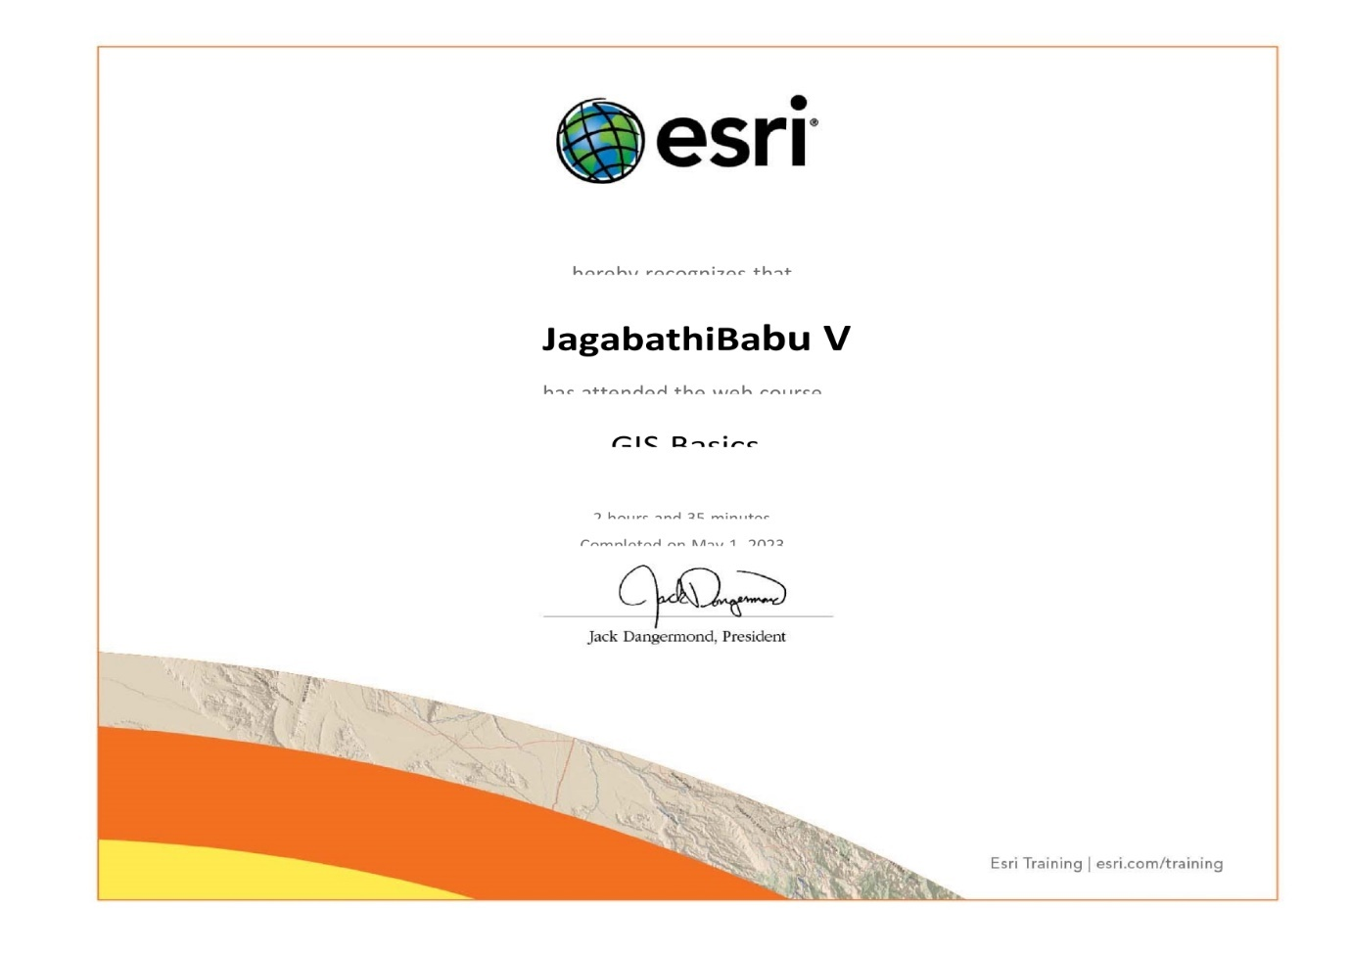

**4.1 GIS Basics Certificate**

**5. FINAL PROJECT**

**A Smart District with basic infrastructure and GIS - a tool that makes lives easier through smart navigation and smart decision making**

**5.1 ABSTRACT:**

Geographic Information Systems (GIS) have been used in many fields of science, technology and business. One of these fields is civil engineering. Spatial information and analysis capabilities have been used to assist the planning, modelling , design and implementation of civil engineering projects and activities. There are many GIS-based tools and applications geared toward civil engineering. Proper use of these tools and applications necessitates training in GIS theory, technology and application-specific issues.

**5.2 INTRODUCTION:**

GIS is the abbreviation for geographic information system. It is a computer-based tool designed to collect, store, process, analyse, visualise and interpret spatially referenced data.

GIS is a useful tool to help answer geographic questions and make decisions.

For example, GIS can be used by climatologists to understand the causes and consequences of climate change, by political consultants to develop campaign strategies for elections or by epidemiologists to locate ground zero of a disease outbreak.

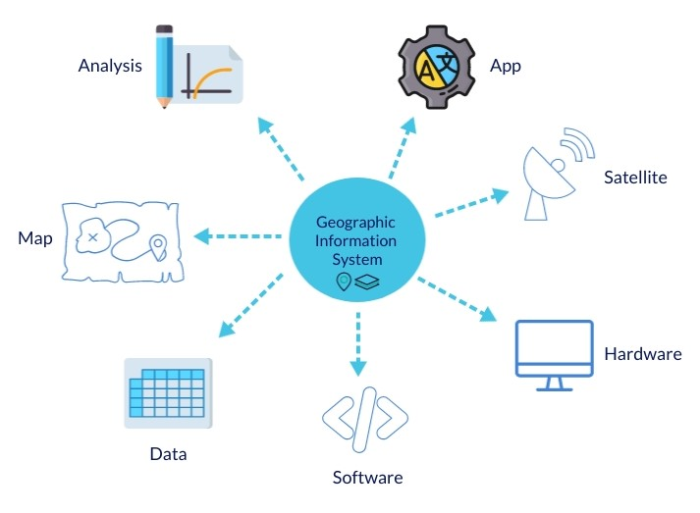

**5.2 Introduction of GIS**

**5.3 COMPONENTS OF GIS**

A working GIS integrates five key components: hardware, software, data, people, and methods.

**Hardware:**

Hardware is the computer on which a GIS operates. Today, GIS software runs on a wide range of hardware types, from centralized computer servers to desktop computers used in stand-alone or networked configurations.

**Software:**

GIS software provides the functions and tools needed to store, analyze, and display geographic information. Key software components are:

· Tools for the input and manipulation of geogrraphic information

· A database management system (DBMS)

· Tools that support geographic query, analysis, and visualization

· A graphical user interface (GUI) for easy access to tools

**Data**

Possibly the most important component of a GIS is the data. Geographic data and related tabular data can be collected in-house or purchased from a commercial data provider. A GIS will integrate spatial data with other data resources and can even use a DBMS, used by most organizations to organize and maintain their data, to manage spatial data.

**People:**

GIS technology is of limited value without the people who manage the system and develop plans for applying it to real world problems. GIS users range from technical specialists who design and maintain the system to those who use it to help them perform their everyday work.

**Methods**

A successful GIS operates according to a well-designed plan and business rules, which are the models and operating practices unique to each organization.

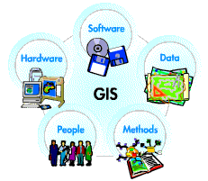

**5.3 Components of GIS**

**5.4 Create Datasets for City Map:**

**5.4.1 Create FGDB:**

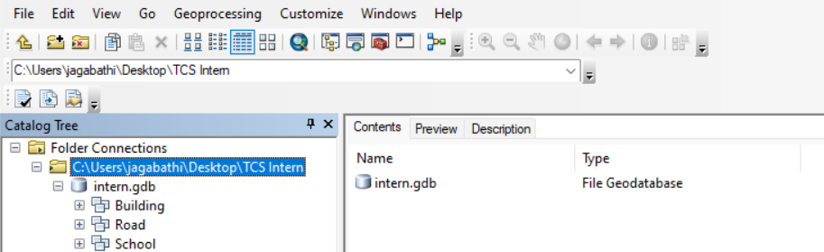

**5.4.2 Create FGDB**

**5.4.2 Create One Point Feature Class for Bus Stops, Check Posts (add attribute to define Bus Stop/Check Post):**

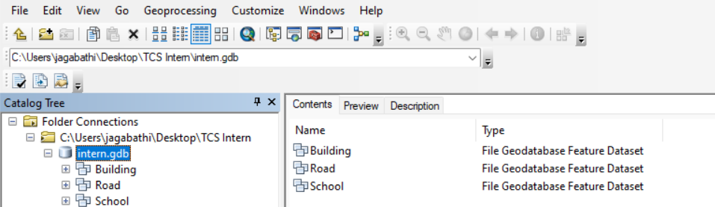

**5.4.2 Create One Point Feature Class for Bus Stops, Check Posts**

**5.4.3 Create point feature class for Buildings (with one attribute to define building type as Hospital/School/Residential/Commerci al along with other attributes):**



**5.4.3 Create point feature class for Buildings**

**5.4.4 Create Line Feature Class for Roads:** 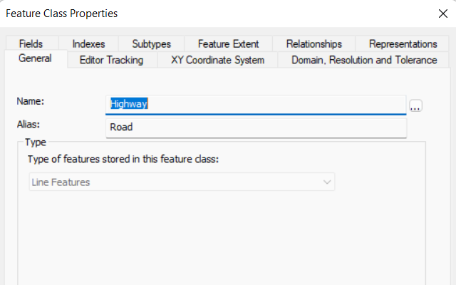

**5.4.4 Create Line Feature Class for Roads**

**5.4.5 Create Polygon Feature Class for Tehseel Bounday:**



**5.4.5 Create Polygon Feature Class for Tehseel Bounday**

**5.5 Define Projections**

**5.5.1 Select same coordinate and projection system for all layers:**



**5.5.1 Select same coordinate and projection system for all layers**

**5.6 Create Data in Layers:**

**5.6.1 Create data in each layer with all attributes filled:**

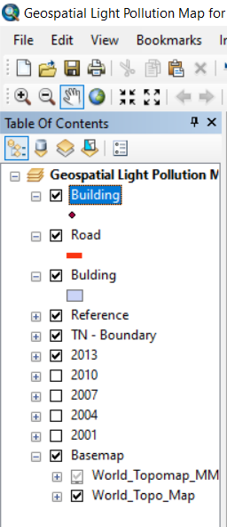

**5.6.1 Create data in each layer with all attributes filled**

**5.7 Define Symbology:**

**5.7.1 Point Layer to define Symbol based on attribute which defines whether it’s a bus stop or check post:**

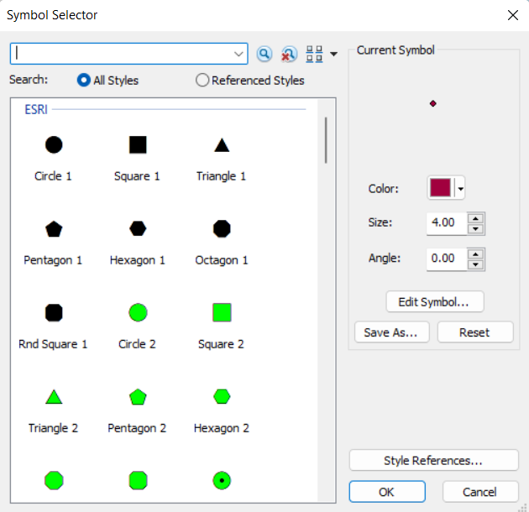

**5.7.1 Point Layer to define Symbol based on attribute which defines whether it’s a bus stop or check post**

**5.7.2 Define Symbol for Tehseel Bounday to show different colors for each Tehseel based on attribute like Name:**

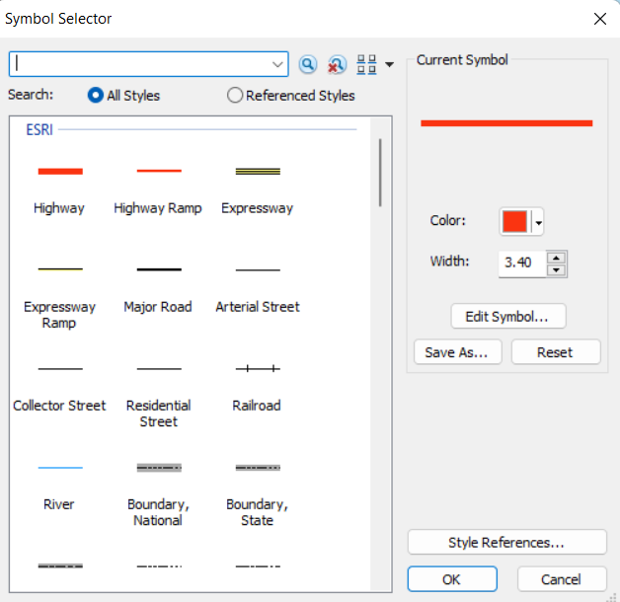

**5.7.2 Define Symbol for Tehseel Bounday to show different colors for each Tehseel based on attribute like Name**

**5.7.3 Define Symbol for each feature in Building layer based on the attribute that defines whether it is Hospital/School.. etc so that each building can be distinguished based on symbol/Color :**

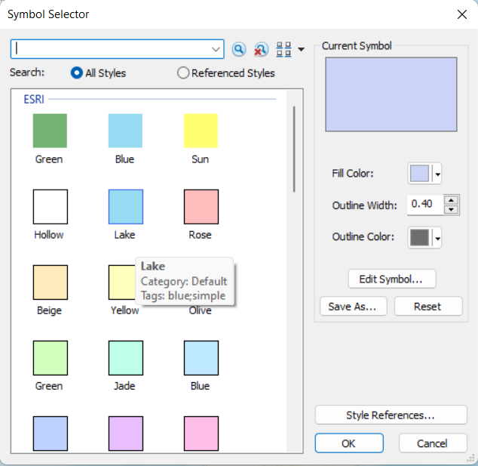

**5.7.3 Define Symbol for each feature in Building layer based on the attribute that defines whether it is Hospital/School.. etc so that each building can be distinguished based on symbol/Color**

**5.8 Save Map Document:**

**5.8.1 After adding all layers in map, save Map Document:**

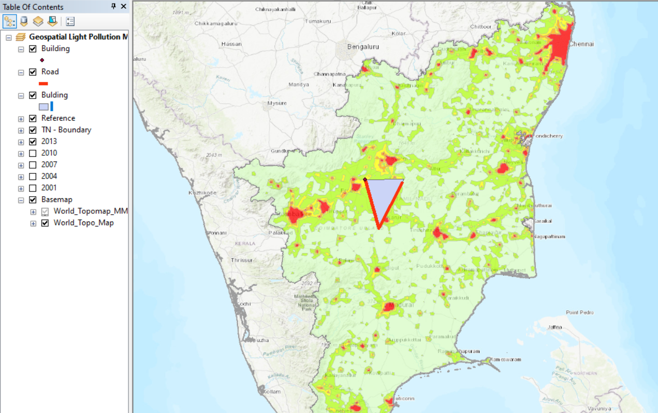

**5.8.1 After adding all layers in map, save Map Document**

**5.9 Query Analysis (Attribute Query/ Spatial Query):**

**5.9.1** **Find any specific road with name query like Mall Road on map:**

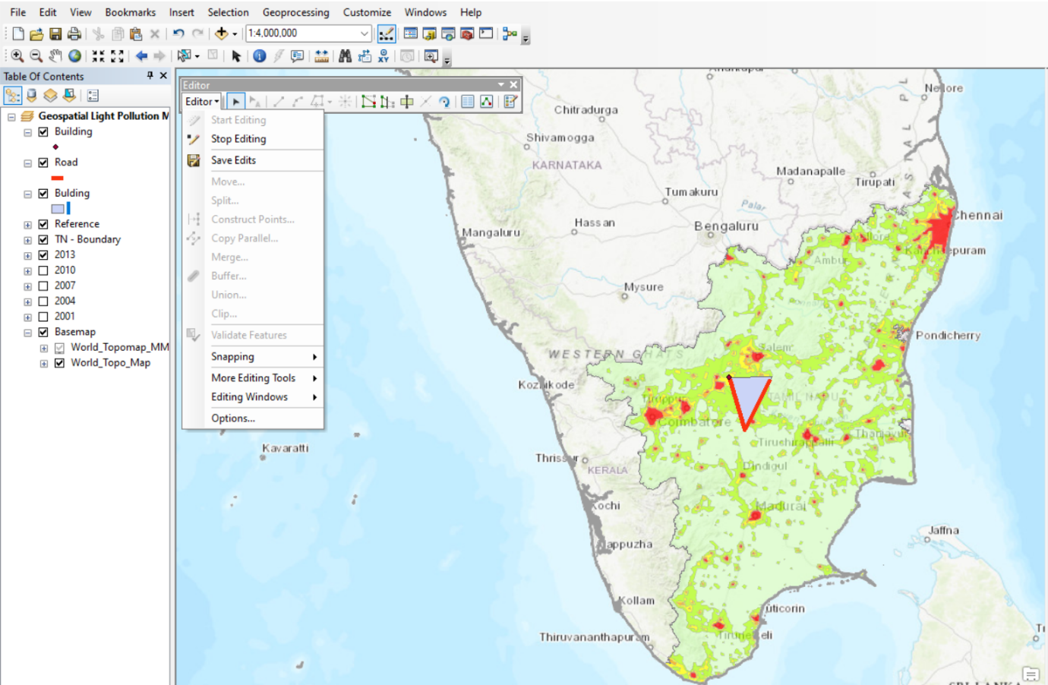

**5.9.1** **Find any specific road with name query like Mall Road on map**

**5.9.2 Find all Hospitals in data:**

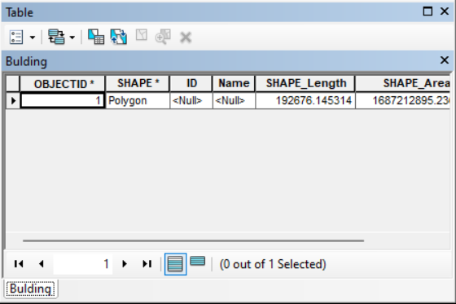

**5.9.2 Find all Hospitals in data**

**5.9.3 Find all schools within 2km distance from my house. (Consider any building which is residential as my house):**

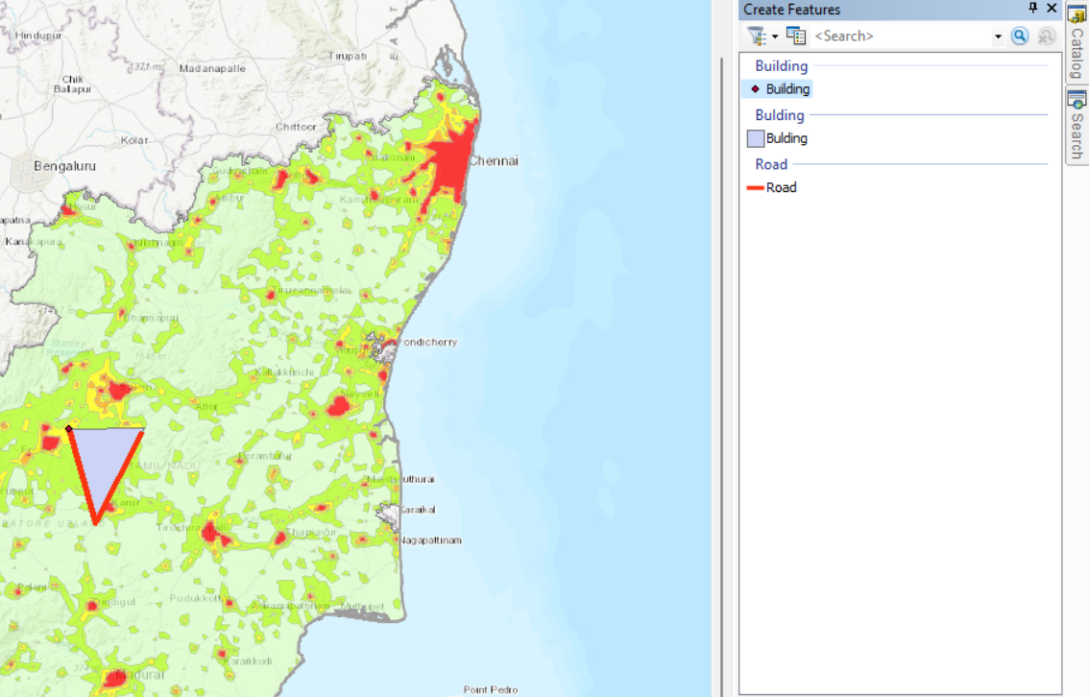

**5.9.3 Find all schools within 2km distance from my house.**

**5.9.4 Find a Bus Stop within 1km of Mall Road:**

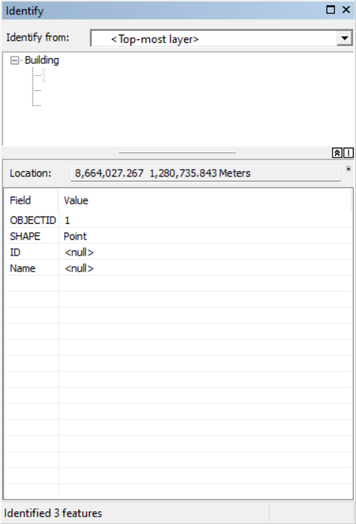

**5.9.4 Find a Bus Stop within 1km of Mall Road**

**5.9.5 Find all commerial buildings in Tehseel..xyz.(find tehseel by name):**

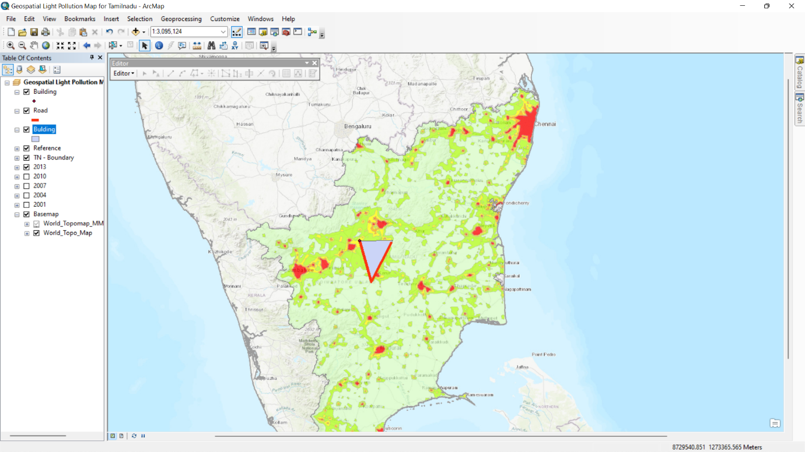

**5.9.5 Find all commerial buildings in Tehseel..xyz**

**5.10 CONCLUSION:**

Map making is an event that we perform everyday. Whether we try to figure out the best route to a neighborhood park or travel cross-country, all of us "make maps." The process of creating maps for academic research is very much the same. Data is gathered about a specific place, verified by theoretical or applied means and analysis is rendered. The ability of applied research to create sophisticated "maps" has been profoundly enhanced by using geographic information systems (GIS). GIS allows users to create, collect, analyze and visualize data in a integrated database for use in a wide array of disciplines. Community based planners can utilize GIS along with contemporary data and local knowledge for capacity-building and long-term sustainability. The use of parcel information and census data as a 'data package' will be explored in this study room. This video is part 8 of 8 in the Applied GIS: Turning Data into Information series.

**5.11 REFERENCES:**

Anselin, Luc, and John O’Loughlin. 1992. “Geography of international conflict and cooperation: spatial dependence and regional context in Africa.” The New Geopolitics, 39–75.

Baddeley, Adrian, Ege Rubak, and Rolf Turner. 2016. Spatial Point Patterns, Methodology and Applications with r. Florida: CRC Press.

Bailey, Trevor C., and Anthony C. Gatrell. 1995. Interactive Spatial Data Analysis. England: Prentice Hall.

Dykes, J. A., and D. J. Unwin. 2001. “Maps of the Census: A Rough Guide.” In Case Studies of Visualization in the Social Sciences: Technical Report 43 (43): 29–54. <http://www.agocg.ac.uk/reports/visual/casestud/dykes/dykes.pdf>.

O’Sullivan, David, and David Unwin. 2010. Geographic Information Analysis. New Jersey, USA: Wiley.

Pebesma, Edzer. 2018. “Simple Features for R: Standardized Support for Spatial Vector Data.” The R Journal 10 (1): 439–46. <https://doi.org/10.32614/RJ-2018-009>.

Roger S. Bivand, Virgilio Gomez-Rubio, Edzer Pebesma. 2013. Applied Spatial Data Analysis with r, Second Edition. New York: Springer.

Sun, M., and W. S. Wong. 2010. “Incorporating Data Quality Information in Mapping American Community Survey Data.” Cartography and Geography Information Science 37 (4): 285–300.

Tobler, Waldo R. 1970. “A Computer Movie Simulating Urban Growth in the Detroit Region.” Economic Geography 46 (2): 234–40. <http://www.geog.ucsb.edu/~tobler/publications/pdf_docs/A-Computer-Movie.pdf>.

**6 FEEDBACK ON INTERNSHIP:**

I had a great experience during my internship at TCS. I was able to work on a project that helped me to develop my technical skills and gain hands-on experience in the field. The team was supportive and provided me with guidance and feedback throughout my time there. Additionally, I had the opportunity to interact with my Team Mates that helped me to improve my teamwork and collaboration skills. Overall, “I am grateful for the experience and feel more confident in my abilities as a result of this internship."